South East & East Anglia Team South East & East Anglia Team
Inter-Regional Obedience Competition Inter-Regional Obedience Competition
Friday 8th March 2024 at CRUFTS Friday 8th March 2024 at CRUFTS
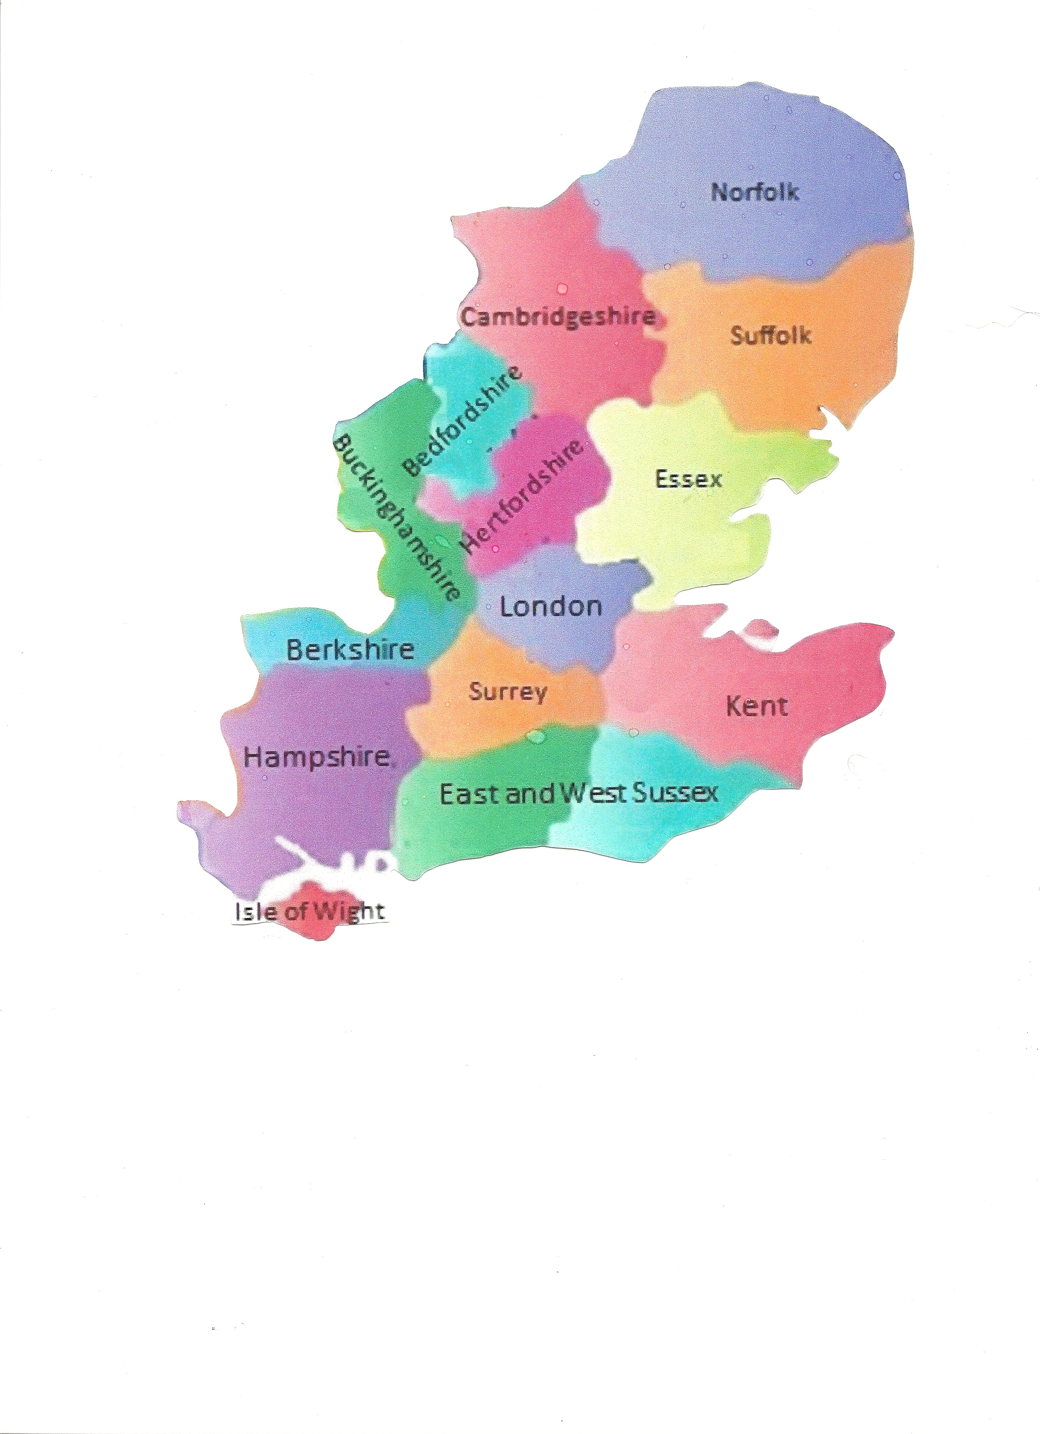
Do you live in one of these counties? Do you live in one of these counties?

If the answer is YES, here is an opportunity If the answer is YES, here is an opportunity
for you to compete at Crufts. for you to compete at Crufts.

We are looking for handlers and We are looking for handlers and
dogs of all breeds to come along dogs of all breeds to come along
to the try-outs in: Beginners, to the try-outs in: Beginners,
Novice, Test A, B & C. Novice, Test A, B & C.

There will be 2 try-out venues in There will be 2 try-out venues in
our area - Berkshire & Essex. our area – Berkshire & Essex.

The Inter Regionals The Inter Regionals
reverted to the reverted to the
Standard G Regs for standard G Regs for
all tests from 2017. all tests from 2017.

For more info or to log your interest contact: For more info or to log your interest contact:
Wendy Birch - Team Manager Tel: 01442 396498 Mobile: 07811911741 Email: wendyanddella@gmail.com

Wendy Birch - Team Manager Tel: 01442 396498 Mobile: 07811911741 Email: wendyanddella@gmail.com

Sarah Delany – Asst. Team Manager Tel: 07919174766
Email: sarahrosedelany@virginmedia.com
Sarah Delany – Asst. Team Manager Tel: 07919174766
Email: sarahrosedelany@virginmedia.com

Enid Diplock – Asst. Team Manager Tel: 07789097134
Email: ediplock@yahoo.co.uk
Enid Diplock – Asst. Team Manager Tel: 07789097134
Email: ediplock@yahoo.co.uk

Go to our dedicated FB page for all documents Go to our dedicated FB page for all documents South East & East Anglia Inter Regional Supporters Group South East & East Anglia Inter Regional Supporters Group

