SHEET 1
GUIDELINES For South East & East Anglia Team
Inter-Regional Obedience competition

This event will take place at the CRUFTS DOG SHOW on Friday 8th March 2024 at the NEC Birmingham. It is an obedience competition between 7 teams from Scotland, Northern Ireland, North, Midlands, Wales, South East & East Anglia, South & South West.

The aim of the day is to show that almost any breed of dog can compete and be successful in Obedience. The five most advanced levels of obedience tests (Beginners to Class C) are on show with the standard ‘G’ regs being used. This means that all tests will be as they are at Kennel Club obedience shows throughout the season and you will not have to perform any different exercises.

TRY-OUT DAYS
It is important that we have a wide choice of dogs of all breeds (including collies) representing all classes to choose from at the try-out days. The more the merrier! The Inter-Regionals are not ‘invitation only’ or a ‘closed shop’. There is not a pre-selection process at the entry stage.
This means that EVERYONE who sends in an entry form is eligible to come along and take part in the try-outs.
Your record of places will help to demonstrate your competitive ability but if you don’t have any yet don’t be put off as what you do at the try-out day is important too. A combination of both things will be considered when choosing the dogs to go forward to the final selection day. On receipt of your entry form you will be added to the list for your chosen try-out date and venue. Confirmation of receipt will be provided.
The final selected team of 8 dogs must not have more than:
3 Border Collies or Working Sheepdogs
3 Crossbreeds (one of which must not be a Collie/WSD type)
3 dogs of any other breed
All dogs selected must be eligible to compete at the class they are selected for on the closing date of 31 October 2023
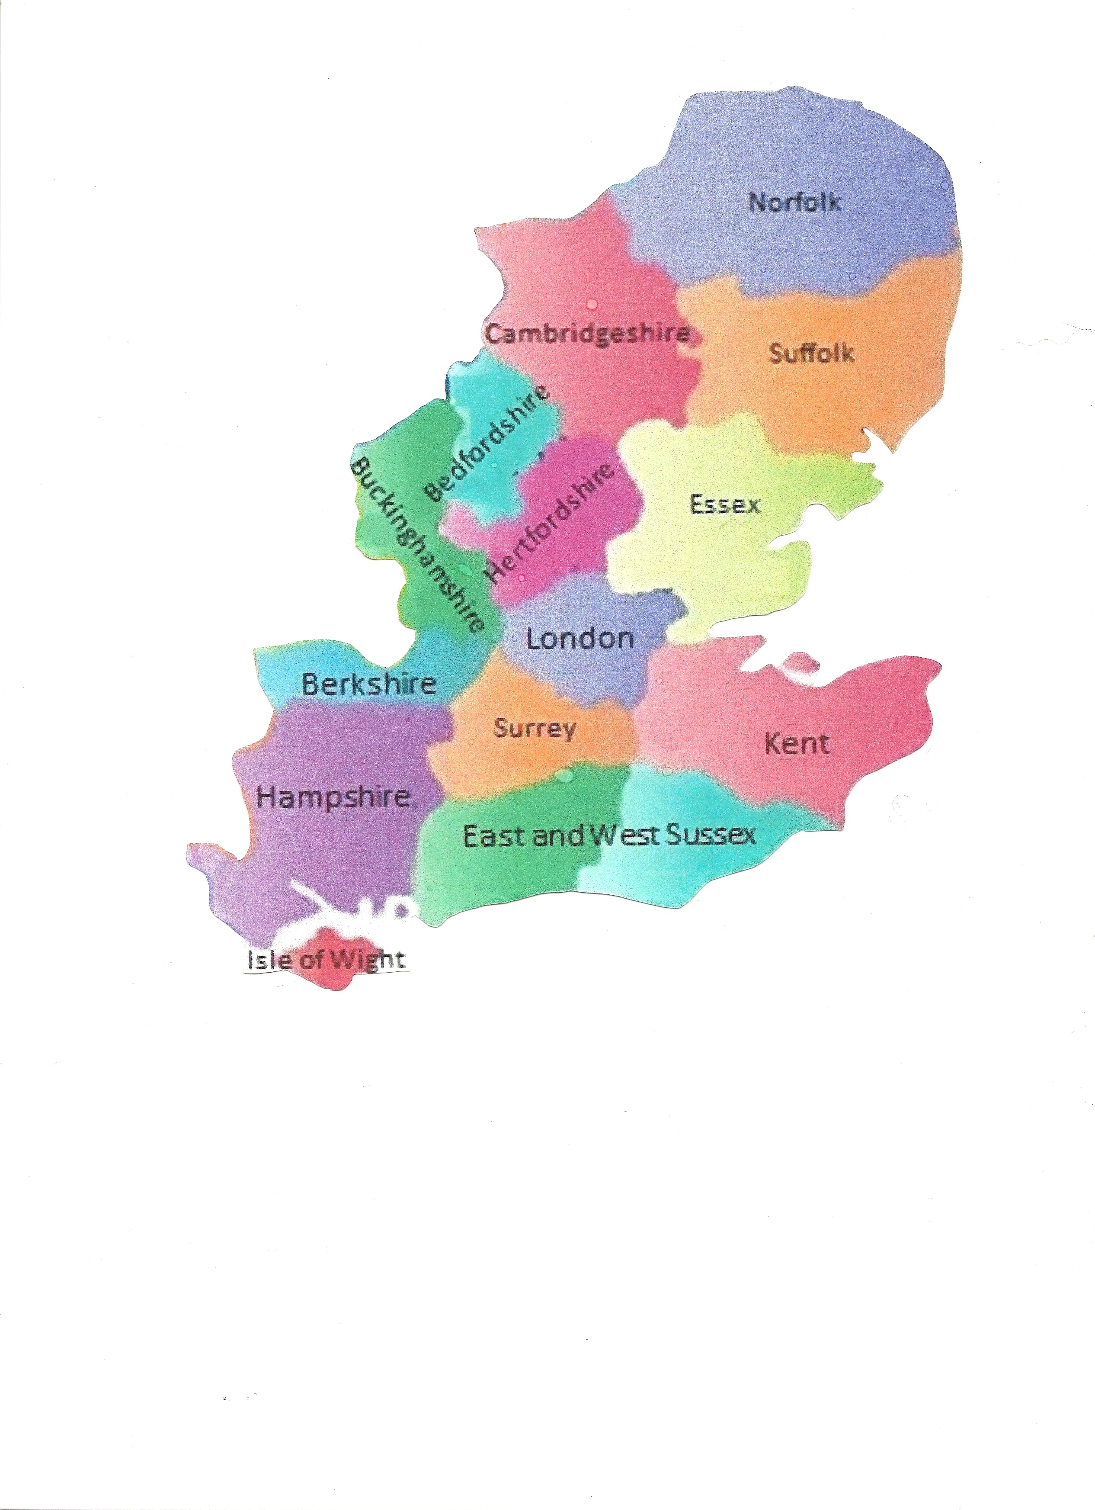

Each team will consist of:
- 1 Beginner dog (plus 1 Beginner reserve)
- 2 Novice dogs
- 2 Class A dogs
- 1 Class B dog
- 1 Class C dog
Making a total of 8 handlers and dogs (including the Beginner level reserve)

- To be eligible for the South East & East Anglia team you must be resident
in one of the counties on this map - (This may be different to your OLC Region…)
- Closing date for eligibility in your chosen class is 31 October 2023, however all entry forms must
be received by Wendy Birch before the date of your chosen try-out.
- Dogs selected for the final team may need to be capable of moving up to the next class
should a dog withdraw from the competition after the closing date for submission
of team details. The Beginner reserve dog will then compete in the Beginner Competition.
- A non-travelling reserve can be chosen for each class, bearing in mind breed
restrictions for the competition. This is at the discretion of each team manager.
- Up to two reserves can be used up to 14 days before the event should first choice
dog and/or handler be forced to withdraw due to ill health or some other serious occurrence. Prior consent to use a reserve must be sought from the Coordinator and Chief Steward.
- There will be no substitutions in the 14 days before Crufts.
- In the event of a tie, the Class C dogs will run off to decide the winning team. There will be no run off in individual classes – in the event of a tie both winners will receive winning points.
- Obedience Champions cannot compete.
- Competitors in the Crufts Obedience Championships 2024 cannot compete.
- Medals and an Award will be presented to the winning team and the runners-up. In addition prize cards will be presented to the winners in each class.
- All tests will be as defined under Kennel Club Obedience Show Regulations (G) in force.
- The 2 try-out and final selection dates and venues are listed on Sheet 2 and entry form Sheet 3.
- Any queries contact Wendy: 01442 396498 / 078119 11741 or South East & East Anglia Inter Regional’s Supporters FB Group.

