SHEET 2

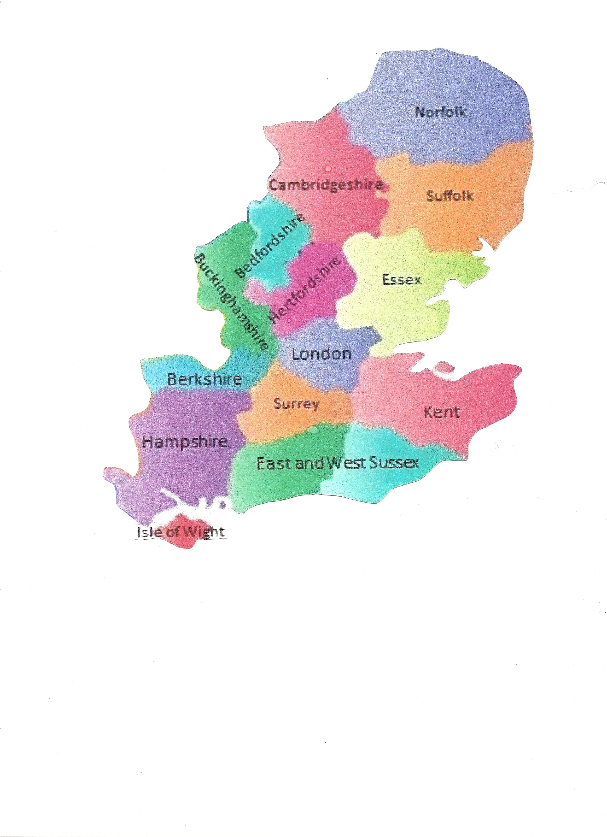
TRY-OUT DATES AND VENUES FOR South East & East Anglia Team
Inter-Regional Obedience COMPETITION CRUFTS 2023

We have chosen two venues & dates in different parts of the SE&EA area for the try-outs and hope that all potential entrants will be able to get to one or other of the venues.

TRY OUT 1 is on Saturday 4th November 2023, starting 9.30am at:
Knowl Hill Village Hall (Thames D.T.C Hall)
The Terrace
Bath Road
Maidenhead
RG10 9XB

TRY OUT 2 is on Sunday 12th November 2023, start 9.30am at: 2
Pebmarsh Village Hall (Halstead D.O.C. Hall) 1
The Street
Pebmarsh
Halstead
Essex
CO9 2NG

THE FINAL SELECTION DATE AND VENUE
At the above two try-out days a number of handlers and breeds will be invited to attend a final selection day when the SE&EA team will be chosen.

This will be held on Saturday 9th December 2023, start 10.00am at:
Flaunden Hall
89, Birch Lane
Flaunden (Near Bovingdon)
Hemel Hempstead
Hertfordshire
HP3 0PW
- This is NOT an invitation only event. NOBODY is pre-selected at the entry stage, EVERYONE who fills in an entry form is eligible to come along and take part in the try-outs.
- You will need to fill out an entry form (Sheet 3) indicating your preferred try-out date(s) and venue(s) and send it in to Wendy Birch before coming along.
- Entry forms will be available to download fromSouth East & East Anglia Inter Regional Supporters Group and obedienceuk.net
- You can either complete and return your entry form by email or print off so you can post.
- If applying for a printed entry form by post, please send a stamped addressed envelope to Wendy Birch, 2 Merrow Drive, Warners End, Hemel Hempstead, Herts, HP1 2LZ
- Please fill in all your wins and places on the entry form for the 2023 season so far. Qualifying date for class eligibility is the 31 October 2023.
- If you are at any shows before your chosen try-out date, please be aware that if you “win out” of a class, this may change your eligibility for the class you would like to try out for…
- The team managers are responsible for selecting their individual team members, but they must include a variety of breeds including collies and crossbreed dogs.
- Please refer to the SE&EA guidelines (Sheet 1) for more information and KC criteria for the competition

